

Programming Fundamentals

Assignment No 9

Student Name :MOMIN HAYAT KHAN

Roll No: S20-0273

Department :BS(Artificial Intelligence)

Batch / Year:SPRING 2020

Lecturer: Mam Misbah

Program No 1:

Write a program in C++ that shows the area of 3 room's. Using Structure namely "distance". Take input of feet & inches from user for variable d1 (feet & inches), assign variable d2 = {10, 5.25} values. Now add feet and inches of d1 & d2 and store in d3.

Display d1 (feet & inches) d2 (feet & inches) d3 (feet & inches) separately. Put Condition if d1 & d2 inches increase by 12 it become a foot.

|  |
| --- |
| #include<iostream>  using namespace std;  struct Distance  {  int feet;  float inches;  float foot;  };  int main()  {  Distance d1;  Distance d2={10, 5.25};  Distance d3;  cout<<"\n-----The area of first room-----\n"<<endl;  cout<<"Enter feet : ";  cin>>d1.feet;  cout<<"Enter inches : ";  cin>>d1.inches;  cout<<"feet : "<<d1.feet<<endl;  cout<<"Inches : "<<d1.inches<<endl;  cout<<"\n-----The area of second room-----\n"<<endl;  cout<<"feet : "<<d2.feet<<endl;  cout<<"Inches : "<<d2.inches<<endl;  cout<<"\n-----The area of third room-----\n"<<endl;  d3.feet=d1.feet+d2.feet;  d3.inches=d1.inches+d2.inches;  cout<<"feet : "<<d3.feet<<endl;  if(d3.inches > 12)  {  d3.foot=d3.inches/12;  cout<<d3.foot<<" ft "<<endl;  }  else  cout<<"Inches : "<<d3.inches<<endl;  return 0;  } |

Output:

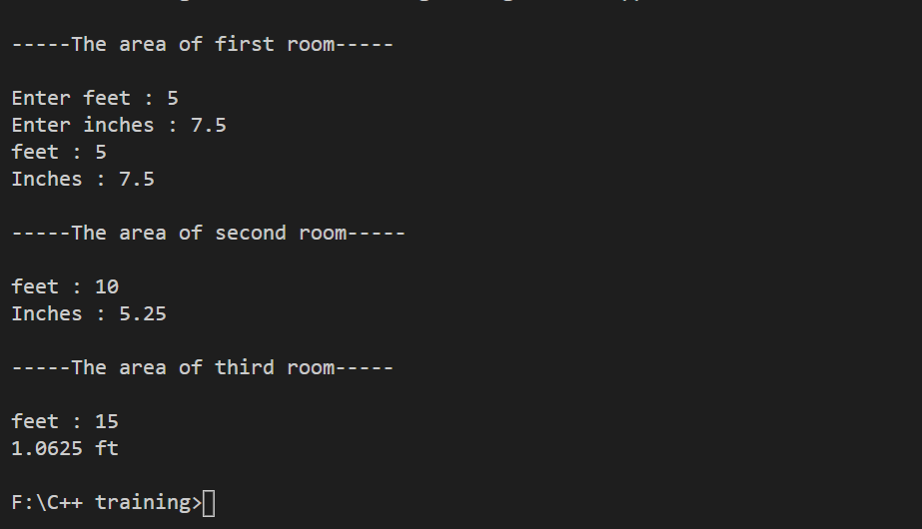

Program No 2:

A phone number, such as 212- 767-8900, can be thought of as having three parts: the area code (212), the exchange (767), and the number (8900). Write a program that uses a structure to store these three parts of a phone number separately. Call the structure phone. Create two structures variables of type phone. Initialize one, and have the user input a number for the other one. Then display both numbers. The interchange might look like this:

|  |
| --- |
| #include<iostream>  using namespace std;  struct phone  {      int code;      int exchange;      long int number;  };  int main()  {      phone ph1;      phone ph2={212,767,8900};      cout<<"Enter the phone number"<<endl;      cout<<"Enter the code : ";      cin>>ph1.code;      cout<<"Enter the exchange : ";      cin>>ph1.exchange;      cout<<"Enter the number : ";      cin>>ph1.number;      cout<<"\n-----The first phone number is-----\n"<<endl;      cout<<"\n"<<ph2.code<<"-"<<ph2.exchange<<"-"<<ph2.number<<endl;      cout<<"\n-----The second phone number is-----\n"<<endl;      cout<<"\n"<<ph1.code<<"-"<<ph1.exchange<<"-"<<ph1.number;      return 0;  } |

Output:

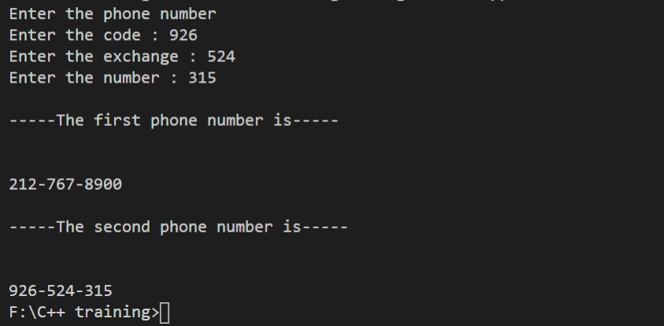

Program No 3:

Create a structure called emp that contains three members, *int id, char name[100], float sal.*

Ask the user to fill in data for three employees and then display information for each employee.

*Hint*

* + *Variable of struct emp will be array*
  + *Use while / for loop to control array*

|  |
| --- |
| #include<iostream>  using namespace std;  struct employee  {  long int ID;  char name[100];  float sal;  };  int main()  {  int i;  struct employee emp[3];  cout<<"-----Enter all employes information-----"<<endl;  for( i=0; i<3; i++)  {  cout<<"\nEnter details of "<< i+1 <<" Employee"<<endl;  cout<<"Employee ID: ";  cin>>emp[i].ID;  cout<<"Name: ";  cin>>emp[i].name;  cout<<"Salaray: ";  cin>>emp[i].sal;  }  cout<<endl;  cout<<"-----All emplyees Information as follow-----";  cout<<endl;  for(i=0; i<3; i++)  {  cout<<"\nDetail of "<< i+1 <<" Employee"<<endl;  cout<<"Employee ID : "<<emp[i].ID<<endl;  cout<<"Employee Name : "<<emp[i].name<<endl;  cout<<"Employee Salary : "<<emp[i].sal<<endl;  }  return 0;  } |

Output:

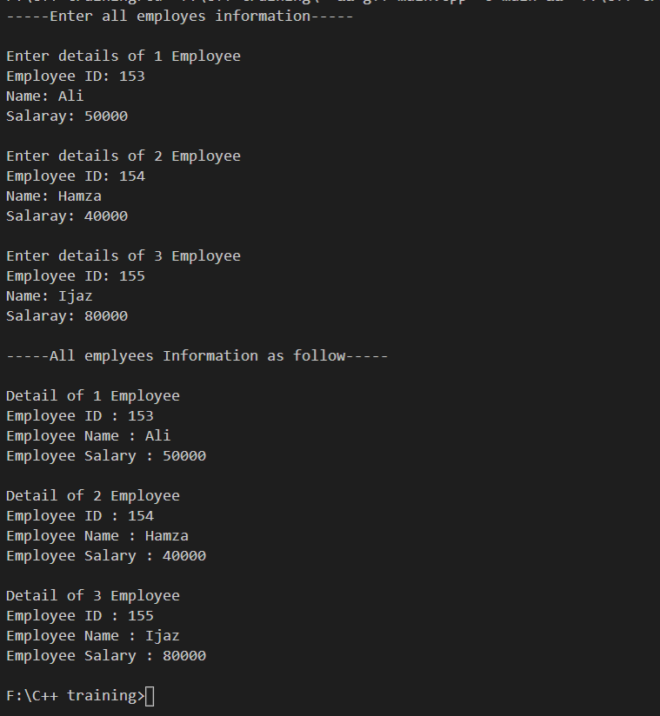

Program No 4:

Write a program using ―sizeof()‖ function that calculate the size of structure.

|  |
| --- |
| #include<iostream>  using namespace std;  struct calc  {     int roll;     char name;     float marks;     float GPA;     char Grade;  };  int main()  {     int size;     struct calc c;     size = sizeof(c);     cout<<"The size of a structure is : "<<size;     return 0;  } |

Output:

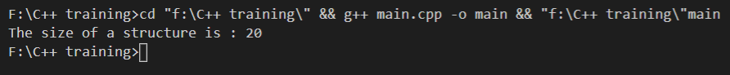

Program No 5:

Write a program to calculates the average age and average GPA of a class having 10 students. Also determine the grade of the class and the student with max GPA. Use a student structure and manipulate it to get the desired result.

|  |
| --- |
| #include<iostream>  using namespace std;  struct student  {  int students[10];  int age;  float gpa;  };  int main()  {  int sum;  float avg, max;  struct student st[5];  for(int i=0; i<5; i++)  {  cout<<"The age of "<<i+1<<" Student is : ";  cin>>st[i].age;  cout<<"The GPA of "<<i+1<<" Student is : ";  cin>>st[i].gpa;  sum=sum+st[i].age;  avg=avg+st[i].gpa;  }  cout<<endl;  cout<<"The average age of a class is : "<<sum/5<<endl;  cout<<"The average GPA of a class is : "<<avg/5<<endl;  if(avg>3.5)  cout<<"The Grade of a class is A+";  else if(avg>3.0)  cout<<"The Grade of a class is A";  else if(avg>2.5)  cout<<"The Grade of a class is B";  else if(avg>2.0)  cout<<"The Grade of a class is C";  else if(avg>1.5)  cout<<"Class is Fail";  cout<<endl;  max = st[0].gpa;  for (int i = 0; i <5; i++)  {  if (st[i].gpa > max)  max = st[i].gpa;  }  cout << "Max GPA is: " <<max;  return 0;  } |

Output:

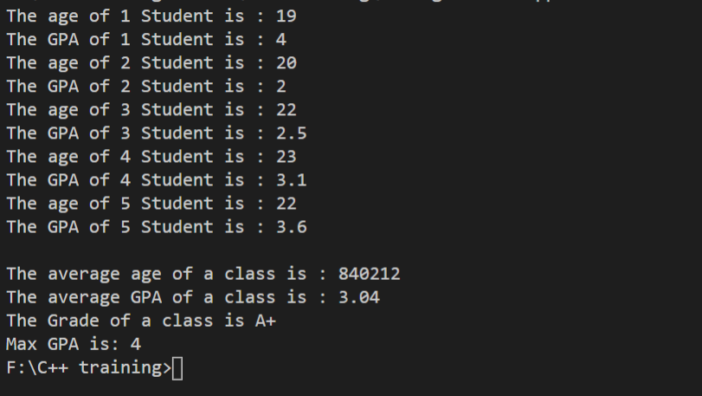

Program No 6:

Write a program that contains nested structure.

|  |
| --- |
| #include<iostream>  using namespace std;  struct address  {  char city[20];  int pin;  char phone[14];  };  struct employee  {  char name[20];  struct address add;  };  int main()  {  struct employee emp;  cout<<"\n-----Enter Employee information-----\n"<<endl;  cout<<"Name : ";  cin>>emp.name;  cout<<"City : ";  cin>>emp.add.city;  cout<<"Pin : ";  cin>>emp.add.pin;  cout<<"Phone # : ";  cin>>emp.add.phone;  cout<<"\n-----Emplye information as follow------\n"<<endl;  cout<<"Name : "<<emp.name<<endl;  cout<<"City : "<<emp.add.city<<endl;  cout<<"Pin : "<<emp.add.pin<<endl;  cout<<"Phone # : "<<emp.add.phone<<endl;  return 0;  } |

Output:

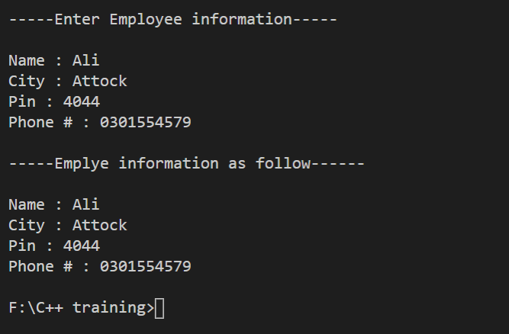

Program No 7:

Access of structure data members with pointer to structure.

|  |
| --- |
| #include<iostream>  using namespace std;  struct student  {      int id;      char name[30];      float percentage;  };  int main()  {      int i;      struct student record = {502, "Ali", 55.2};      struct student *ptr;      ptr = &record;      cout<<"\n----- Student Record-----\n"<<endl;      cout<<"  Id is: "<<ptr->id<<endl;      cout<<"  Name is: "<<ptr->name<<endl;      cout<<"  Percentage is: "<<ptr->percentage;  } |

Output:

